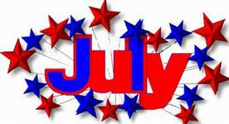

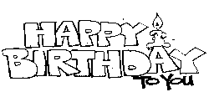

July 1 ………………………………… Jenna Parker
July 2 ………………………………… Darien Evans
Kelly McSwain
July 3 ………………………………… Linda Frady
July 11 ………………………………... Dylan Evans
July 13 ………………………………… Jane Mauney
Amy Creech
July 16 ………………………………… Rick Stewart
July 20 ………………………………… Joann Gantt
Savanna Curtis
July 22 ………………………………… Elizabeth Black
July 25 ………………………………… Liz Hullender
July 26 ………………………………… Scott Miller
July 28 ………………………………… Hunter Leatherman
July 29 ………………………………… Dorothy Brown
July 31 ………………………………… Ricky McDonald

